Hi, Media friends! So glad that you are interested in viAct.ai. Here below are some information and material tailored for you.

Please contact gary.ng@viact.ai if you want a personal chat and any resources from us.

Company Overview
English Version

We are viAct.ai, a computer vision solution that automates construction monitoring to increase productivity, safety and reduce delay. We can detect workers fall down the incident and trigger real-time instant alerts to save a life. We can track the location of different materials in the construction sites to speed up material allocation and anticipate site risk due to obstacles in the critical walk path. We can detect if the worker wears a safety helmet, belt, and jacket to improve the personal safety level. We can track worker’s Identification, facilitate project managers to identify which subcontractors doing their planned works and how long they have been working in the monitoring area in order to secure productivity. We can also define the danger zone and alert workers when they have entered to avoid an accident. Last but not least, we can track the number and type of machinery on-site for better scheduling i.e. specified vehicles and large size machinery.

Our solution can connect with any type of online cameras, the user simply selects from multiple visual engines to enjoy real-time alert, collect data and get insights in the dashboard. There is no coding required, anyone can set up in our platform within 5 minutes. It is simple to set up multiple detections with high flexibility with real-time alerts.

Chinese Version

我们是视动智能viAct.ai致力于打造智慧工地，是香港第一家布局针对建筑行业的云视频监控平台。针对行业痛点为建筑业企业开发专用的计算机视觉引擎，建立一站式人工智能平台，实时高效地检测施工现场设备、车辆及工人的安全故障、资源分配和生产效率等关键因素。我们的云端设备能根据从摄像头和移动应用程序中获取的视频和图片信息进行实时数据分析，生产深度检测报告，从而自动化现场监测和管理流程。就拿我们的一个案例来说，每次在施工上对承包商施工人员的监控不仅需要部署人力在工地，在后台，还有假设24小时不断的视频监控，后台人员倒班监看。其主要目的就是观察施工方是否懈怠工作，没有佩戴安全设备，违反安全守则，设备是否摆放到位，人员、车辆是否按时到达现场。通过前期积累的人工智能技术及建筑工地独特的数据，视动智能已经在部分违规操作，诸如懈怠工作，没有佩戴安全设备，违规吸烟、打架等方向上实现自动监控的能力，并正在进一步向完整落地努力。

viAct.ai能与任何摄像设备连接，并且设备搭建仅需5分钟。这为企业提供高度灵活性和便利性。我们的做法是全方位的升级现有视频智能监控和感知的能力，通过深度学习算法帮助从业人员提高工作效率和能力。创始人伍震驱先生Gary通过多年在建筑及高科技工作的努力，积累了行业大量的AI解决能力，并在2019年入住香港科学园HKSTP，同时获得China Accelerator及香港人工智能研究所HKAI Lab 加速器投资，现正寻求种子轮融资。

Background:

Everyone knows the construction industry is one of the largest world economy with USD 24 trillion worth in 2021. But construction companies in general making only 2% profit margin for each construction project. Because the construction worker’s productivity has a zero increase in the last 25 years while their labor cost has been continuously increased by 3.8% annually. Also, 98% project got delay and overrun 20 months and cost increase by 80%. Every year statistic shows, one in every 10 construction workers got injured which accounts for 6–9 percent of project costs. One fatal injury costs an average of USD 1 million in hospital costs.

Today more than 80% of construction companies already implemented real-time monitoring to improve quality, productivity, and safety. But the monitoring is still done by human which is basically impossible to get reliable data and insight.

Chinese Version

从政策端看，国务院印发《“十三五”国家信息化规划》指出，到2018年，分级分类建设100个新型示范性智慧城市；到2020年，新型智慧城市建设取得显著成效，形成无处不在的惠民服务、透明高效的在线政府、融合创新的信息经济、精准精细的城市治理、安全可靠的运行体系。智慧城市的发展必将进一步推动智能建筑行业向前发展。

在需求端，相较于欧美国家，我国建筑智能化工程行业发展仍不充分。但总体上说，中国智能建筑普及程度仍远低于欧、美、日等发达国家，我国智能建筑占新增建筑的比重仅为日本的一半，未来需求不论从新建还是改装来说都很充足，发展空间广阔。

在建筑机器人的研发与实践这条路上，碧桂园已走在前列，但很显然他们还有实现智慧建造的更高追求。此次全国“两会”上，杨国强委员建议应从政府层面加强对人工智能和建筑机器人深度融合的引导和支持，积极推进制定行业标准，加速建筑机器人的应用。他对此很有紧迫感。他表示，科技的进步不可想象，今天加大对科技的投入正是时候，如果再不努力的话就将落后了。纵观整个智能建筑行业，亟需突破的细分产业还有很多，除了传统房地产商的积极自我突破，并持续的投资，传统互联网产业、硬件设备制造商也在积极寻找自己的位置，传统工业化软件的落后已经成为智能建筑向前发展的绊脚石，而传统硬件制造商的软件实力不济也一部分造成了智能化迟迟得不到有效的进展。相互结合优势，通过软实力积极拓展硬件设备制造商在智慧建筑的用例，既能减少行业的门槛，也能帮助产业的快速智能化的推进.
Website: www.viAct.ai
Company incorporated: Customindz Ltd. incorporated in HK on Dec 2016
Latest product launch: viAct.ai platform launch in Sep 2019
Founder : Mr. Gary Ng
Location: Headquartered in Hong Kong.
Address: Unit 603-607, 6/F, Lakeside 2 10 Science Park West Avenue Hong Kong Science Park, Shatin, N.T.
Employees: 10+

Our mission
Make video data insightful and rewardable to enterprises

Our vision
Using computer vision to anticipate risk and maximize productivity

Our values
We value human life, care about teamwork and customer happiness

Our culture
Extremely open-minded, responsible, sharing, keep learning and trying new things

Our mantra
Beyond Human Vision
Founder Bio
Gary Ng
Founder and CEO – viAct.ai

Gary is a serial entrepreneur who is the Founder and CEO of viAct.ai, a computer vision solution for smart construction and manufacturing. He is graduated as building engineer and working in a professional construction consultancy firm for years. Before his entrepreneurial journey, he was serving as Managing Director and Sales Director for leading NASDAQ listed technology companies in Stratasys and EFI Optitex. In 2015, he is rewarded as the best regional manager in Stratasys in the world with the highest Y2Y sales growth of 85%.

Gary是viAct.ai的创始人兼首席执行官，他毕业于蘇格建筑工程，并在一家专业的建筑咨询公司工作了多年。在他的创业之旅之前，他曾在美國纳斯达克上市3D打印企業Stratasys和以色列全球领先的服裝生產科技公司EFI Optitex担任董事总经理和销售总监。 2015年，他获得Stratasys最佳全球区域经理的称号，其Y2Y销售额增长率最高，达到了85％。

Team
Our team has rich experience in business development, AI and construction.

Danny Huang is our Head of Data Science who is working in AI for more than 10 years and published more than 10 research papers in AI and big data. Izaac Leung is our chief AI officer who has implemented more than 5 research projects in AI relating to construction in the last 3 years. Donald Yueng is our full-stack engineer who is previously working for ZTE and Google and completed more than 20 startup products in the last 10 years.
Founder Quote
“INNOVATION IS KEEP TRYING NEW THING TODAY EVEN IT MAY FAIL TOMORROW” ——Gary Ng, CEO of viAct.ai
Investor List
viAct.ai is currently invested by Alibaba entrepreneurs fund, SOSV, and Sensetime and currently incubated by Chinaccelerator, HK science park and TusPark. We are working with one of the largest construction companies in Hong Kong, Singapore, and Macau and we are the approved solution provider from the largest government agencies in the construction and manufacturing industry.
Seed Round

1)HKAI Lab – Alibaba Entrepreneurs Fund / HKSTP / SenseTime

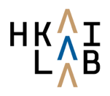

https://www.hongkongai.org/

2)Chinaccelerator – SOSV

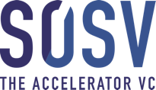

https://chinaccelerator.com/ https://sosv.com/
Social Media
Wechat : 视动智能
Linkedin : https://www.linkedin.com/company/viactai/
Media Coverages
港產職安平台AI做監工 實時視察地盤 遇事即通報 | Startupbeat
http://startupbeat.hkej.com/?p=79325

先收訂金避免拖數 | Startupbeat
http://startupbeat.hkej.com/?p=79335

3 Top Tailored Tech Services – Startup Zone 2018 | Befast TV
https://befast.tv/startup-zone-day-4/

Brand Recognition
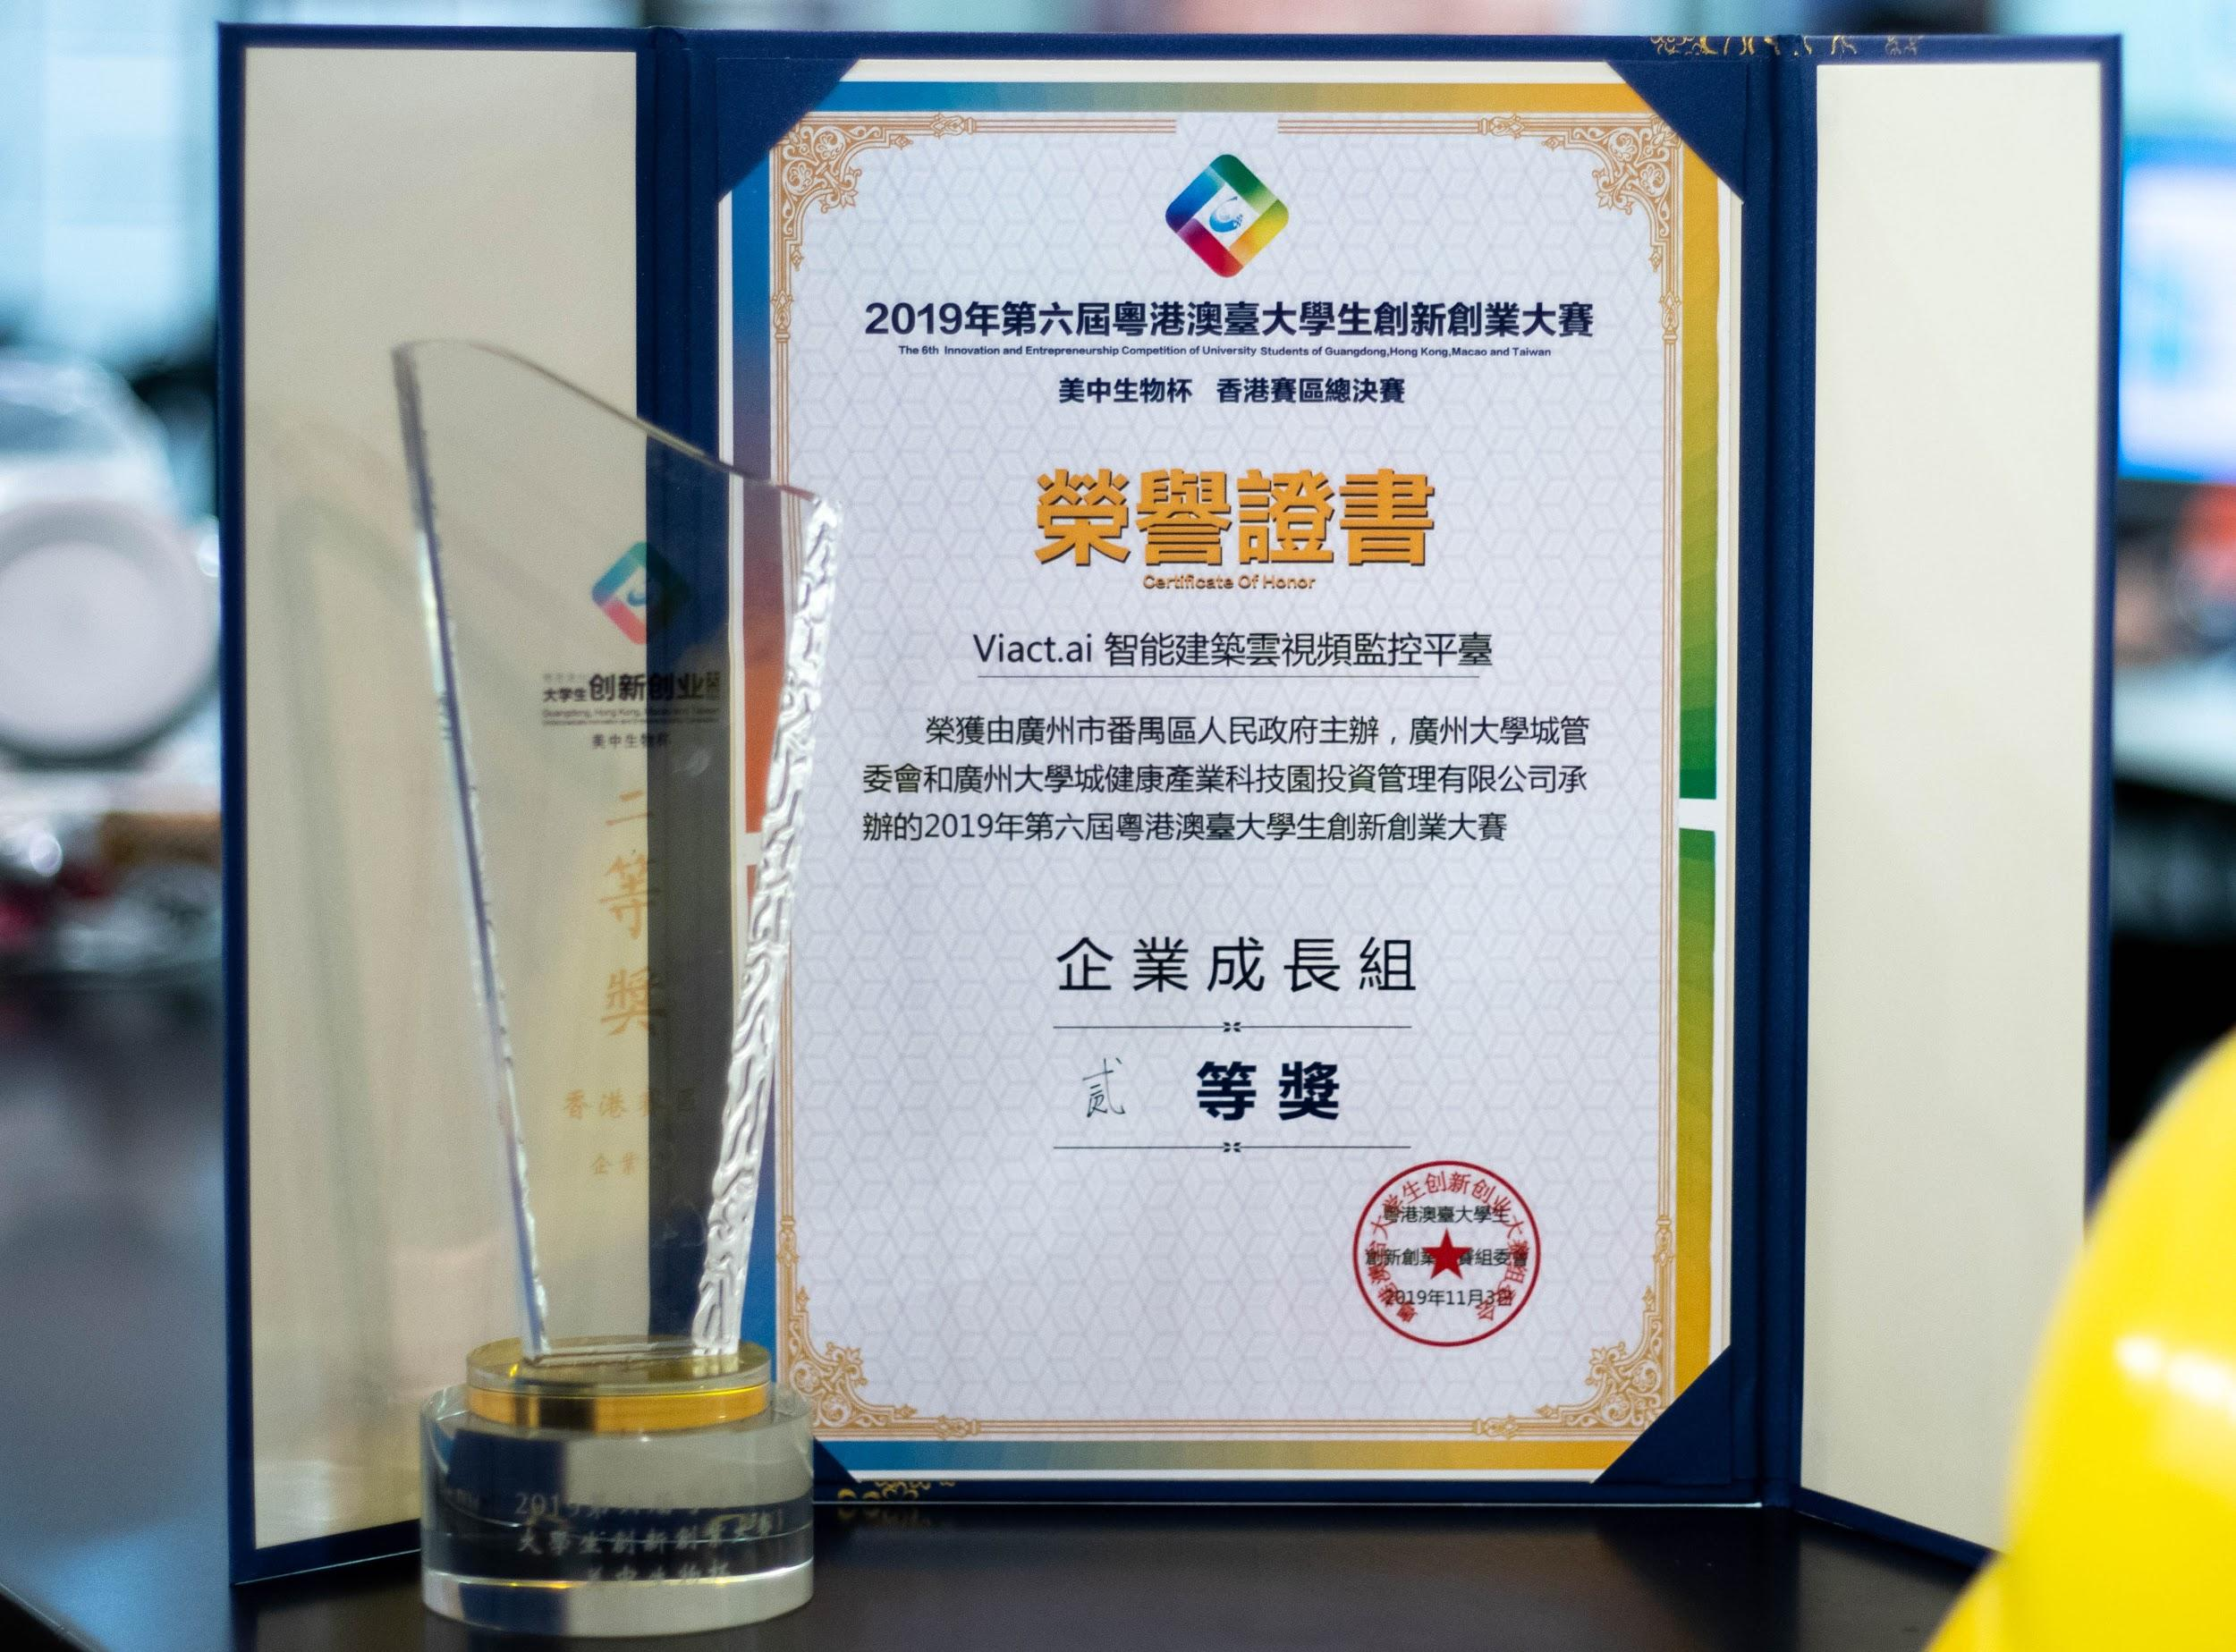
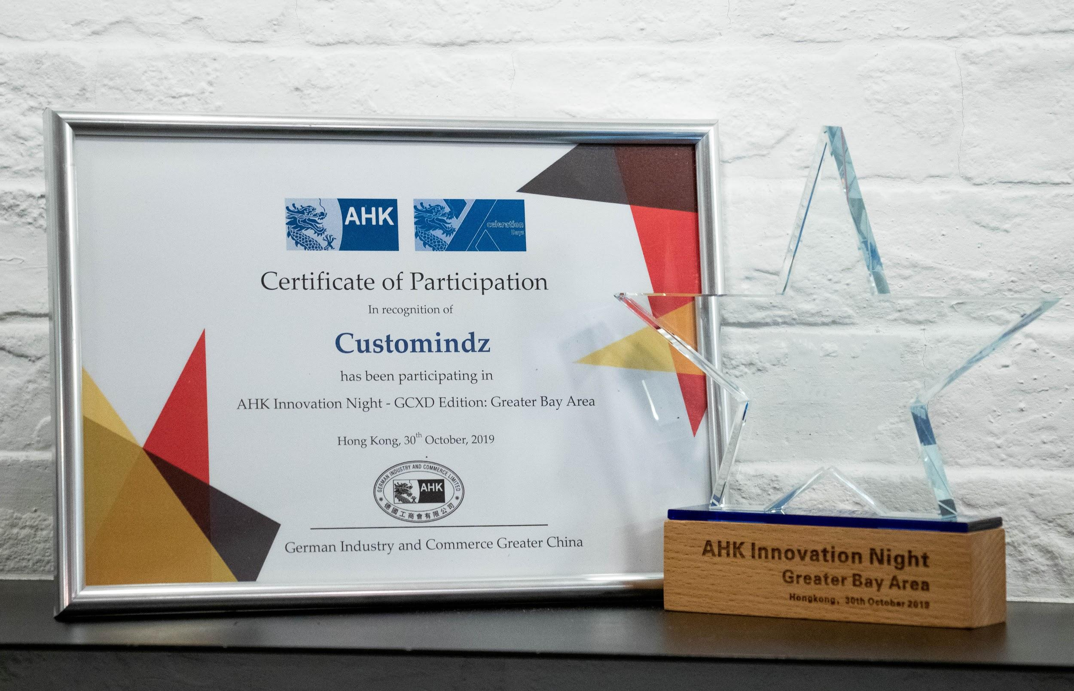

Product Photos
